COVER PAGE

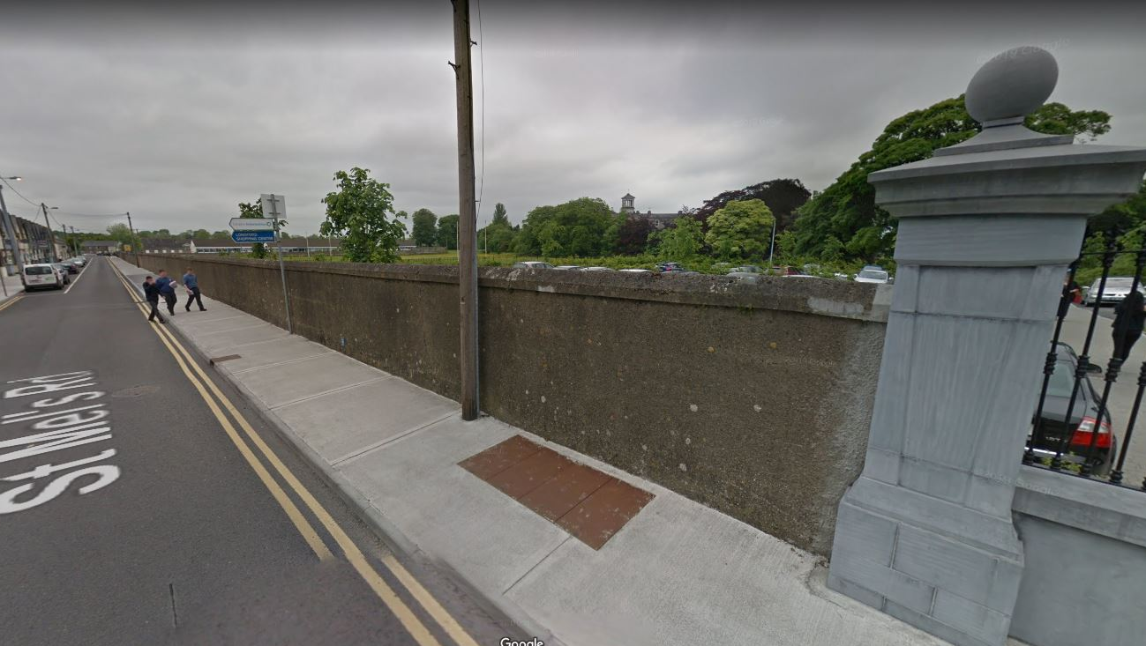

Reconstruction of existing St. Mel’s Road boundary wall, a protected structure, involving the continued wall type as was previously constructed under Planning Reference No. 14/700011 at St. Mel’s College, at Townsparks and Deanscurragh, Longford Town, Co. Longford.

SCHEDULE

- Development Description
- Newspaper Notice
- Site Notice
- Site Plan, Elevation & Section

DEVELOPMENT DESCRIPTION

Reconstruction of existing St. Mel’s Road boundary wall, a protected structure, involving the continued wall type as was previously constructed under Planning Reference No. 14/700011 at St. Mel’s College, at Townsparks and Deanscurragh, Longford Town, Co. Longford

The reconstruction of an approx. 160m length of existing boundary wall shared between St. Mel’s Road and St. Mel’s College, compromising of a 500mm high limestone clad plinth wall with coping and 1500mm high, powder coated black, steel railings above, as a continuation of the wall as previously constructed, extending to the boundary with St. Michael’s National School. The proposal also involves the railed enclosure of an existing, pedestrian entrance to the car park off St. Mel’s Road.

